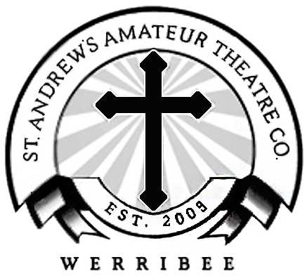

St. Andrew’s Amateur Theatre Company

“Step Into The Spotlight”

Code of Conduct

Being a member of the St. Andrew’s Amateur Theatre Company means that we all must behave in a safe, fair and respectful manner.

All members will:

- Commit to rehearsals, learn lines, songs, dances and participate in a positive manner during rehearsals.
- Listen and follow all directions given by the production team and committee.
- Engage in all rehearsals, shows and events in a positive manner that represents the vision of St. Andrew’s Amateur Theatre Company.
- Treat all members with courtesy and dignity.
- Remain within the safety of the rehearsal and show venue and respect the facilities.

Our Community will not tolerate discrimination, bullying, physical/verbal or sexual harassment.

Rehearsal and show venues are alcohol, smoke and drug free zones.

Any breach of the Code of Conduct will be referred to a member of the St. Andrew’s Amateur Theatre Company Committee.

Name:
Signature:
Date:

